**Collection**

Collection Interface extends another interface called ‘Iterable’ interface.

Iterable Interface allows use to create an object called Iterator.

The top most interface in the collection framework is ‘collection’ interface.

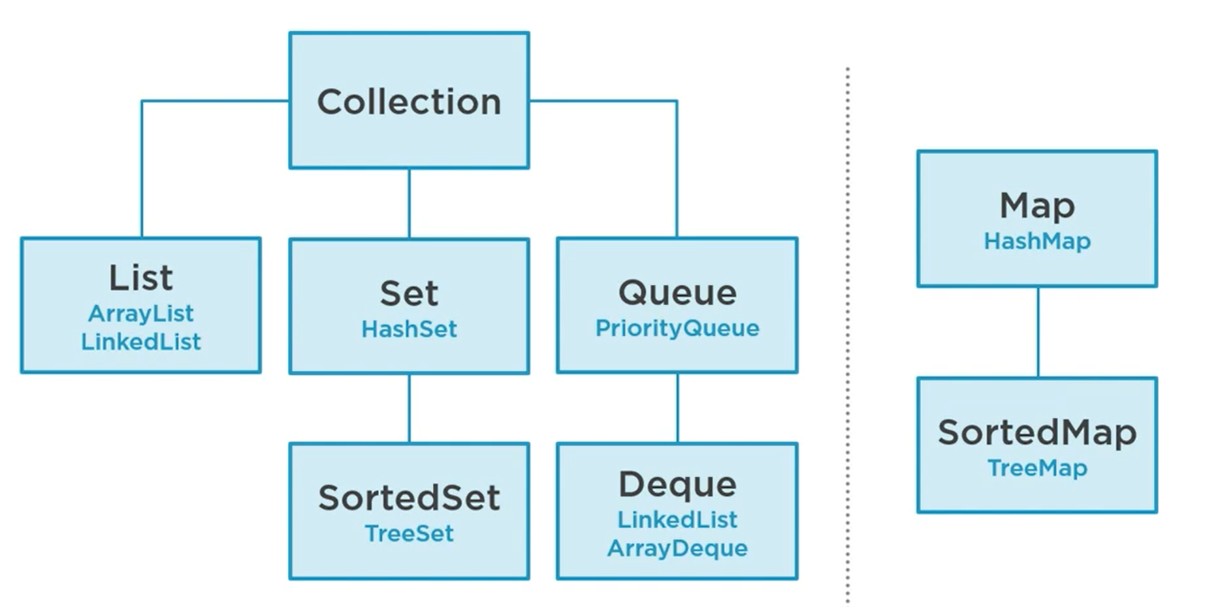

List, Set/Sorted Set, Queue/Deque: these interfaces are extended to collection interface.

Map/Sorted interface doesn’t actually extend the collection interface though it is part of the collections framework, has the HashMap implementation and SortedMap has the TreeMap implementation.

Map is the only collections that don’t extend or implement the collection interface.

**When to use which collection interface?**

